R1 200k; R2 10k; R3 92k; R4 100k; R5 10k; R6 1k; R7 461; C1 ; C2 1.5-15uF; C3 ; C4 ; C5 10uF;

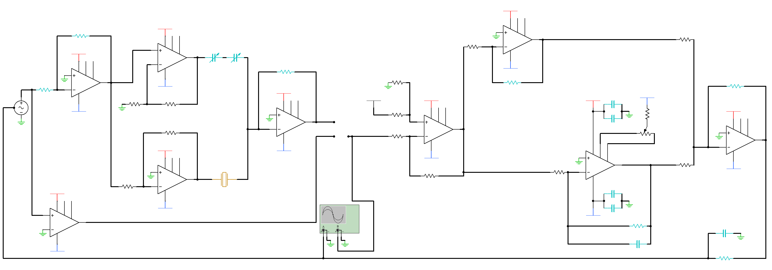

RB

RB

RD

RC

RB

RB

RB

RB

RB

RB

RA

RA

RA

RA

**Differential Amplifier**

V-

V-

V-

V-

V-

V-

**TIA**

V-

V-

V-

V-

**Equilizing OpAmp**

V+

**Sine-to-Square Converter**

V+

V+

V+

**Non-Inverting Amplifier**

V+

V+

V+

V+

***PI Controller***

V+

VREF

C1

**Inverting Amplifier**

***Compensating Unit***

**Low-Pass Filter**

**OpAmp Summer**

**OpAmp Integrator**

**Proportional Amplifier**

**QTF**

***LIA***

***OSC***

**FG**

C5

R7

R6

R5

C4

C3

C4

C3

R4

R3

C2

R1

R2